Modeling and Simulation

Course: MODELING AND SIMULATION (MD-304)
Assignment 3: Simulink Models for Soil Classification

Submitted To: Dr. Jawad Hussain
Name: Ahamd Akram
Roll No: 23-CE-111

Table of Contents
Assignment 3: Simulink Models for Soil Classification 1
1. Abbreviations 3
2. Introduction 3
3. Methodology: Building the Models Manually 3
3.1 Step 1: Setting Up the Inputs 3
3.2 Step 2: Calculating the Plasticity Index (PI) 3
3.3 Step 3: Building the USCS Logic 4
3.4 Step 4: Creating the USCS Output 5
4. Final Simulink Model Diagrams 6
4.1 USCS Model 6
4.2 AASHTO Model 7
5. How to Use the Models 7

1. Abbreviations
- AASHTO: American Association of State Highway and Transportation Officials
- USCS: Unified Soil Classification System
- LL: Liquid Limit
- PL: Plastic Limit
- PI: Plasticity Index

2. Introduction
For this assignment, two models were built manually in Simulink to classify soil type based on standard laboratory test results. One model implements the Unified Soil Classification System (USCS), and the other implements the AASHTO classification system. The models were constructed block by block to visually represent the logic of each classification standard.

3. Methodology: Building the Models
The following steps describe the manual, drag-and-drop process used to build the USCS model. A similar process was followed for the AASHTO model.

3.1 Step 1: Setting Up the Inputs
The first step is to add the input blocks for the soil properties.
- From the Simulink Library Browser, three Constant blocks (Simulink/Sources) were dragged onto the canvas.
- These blocks were renamed and configured to represent the primary inputs:
Percent Passing 200
Liquid Limit
Plastic Limit

3.2 Step 2: Calculating the Plasticity Index (PI)
Next, the Plasticity Index (PI) is calculated from the LL and PL.
- A Subtract block (Simulink/Math Operations) was added to the model.
- The output signals from the Liquid Limit and Plastic Limit blocks were connected to the inputs of the Subtract block. The output of this block
represents the PI.

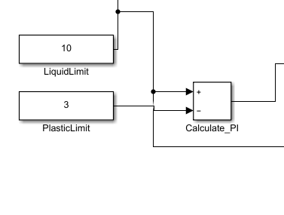
Figure 1Calculating Plasticity Index

3.3 Step 3: Building the USCS Logic
This is the most complex part where the USCS rules are implemented.
- Several compared To Constant blocks (Simulink/Logic and Bit Operations) were added to check if the inputs (P200, LL, PI) were greater or less than the
standard threshold values (e.g., is P200 > 50?).
- Logical Operator blocks (Simulink/Logic and Bit Operations) set to 'AND' were used to combine the results of these comparisons. For example, to check
for 'CL' soil, the logic (LL < 50) AND (PI > 7) was built.

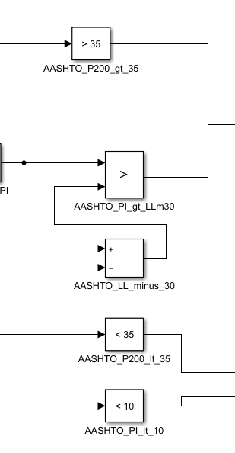
Figure 2:Logical Operator Blocks

3.4 Step 4: Creating the USCS Output
Finally, a series of switches selects the correct soil classification string to display.
1. String Constant blocks (simulink/String) were created to hold the possible output values (e.g., 'CH', 'CL', 'SW').
2. Switch blocks (simulink/Signal Routing) were added. The output of the logic from Step 3 was connected to the control port (the middle input) of each
Switch.
3. The Switch blocks pass through the correct string based on the logic. The final output is fed into a Display block (simulink/Sinks) to show the
result.
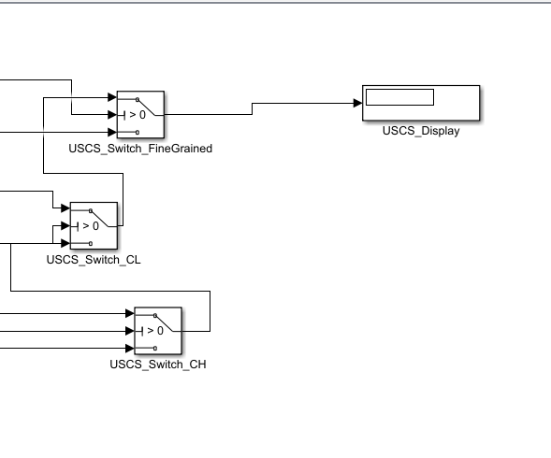
Figure 3:Switches And Output

4. Final Simulink Model Diagrams

4.1 USCS Model
The following image shows the complete, constructed Simulink block diagram for the USCS model.

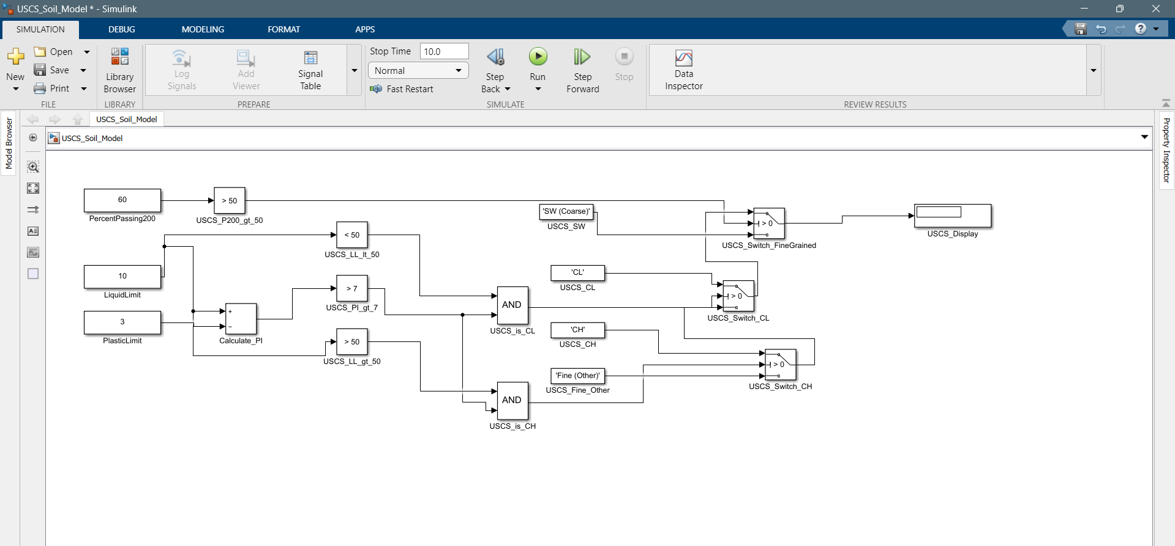
Figure 4:USCS Model

4.2 AASHTO Model
The following image shows the complete,
constructed Simulink block diagram for the AASHTO model.

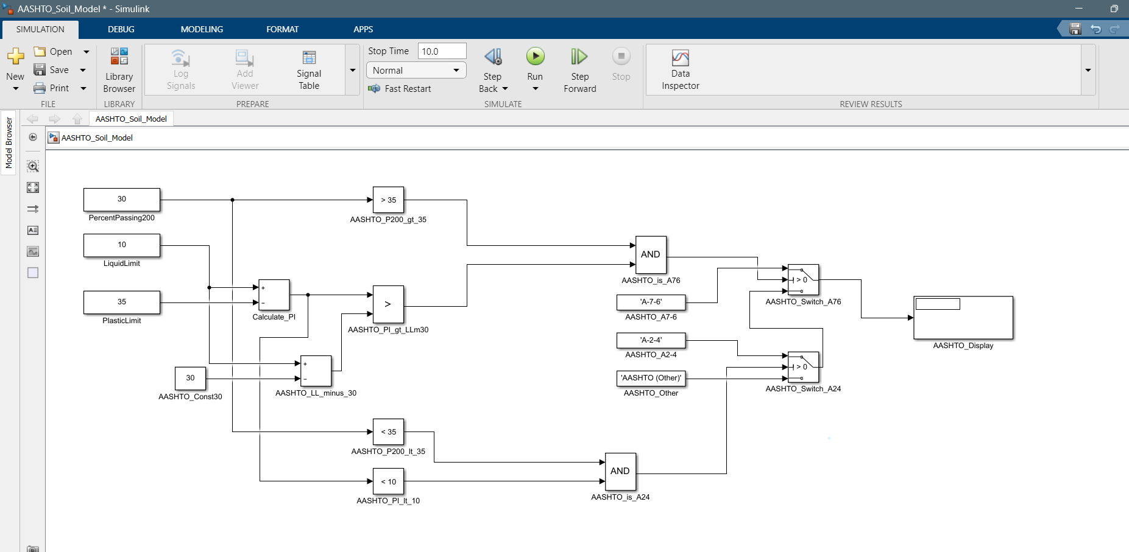
Figure 5:AASHTO Model

5. How to Use the Models
- Open the .slx model file in Simulink.
- To change the input values, double-click the Constant blocks on the left side of the model and enter a new value.
- Click the green "Run" button in the Simulink toolbar to execute the simulation.
- The final soil classification will appear in the Display block on the right.
- Sample Results
The models were tested with a sample soil to verify their functionality.
Test Soil: A Clay Soil
Inputs:
  - Percent Passing #200 = 60
  - Liquid Limit = 55
  - Plastic Limit = 28
  - Calculated PI: 20
Results:
- The USCS Model returned: 'CH'
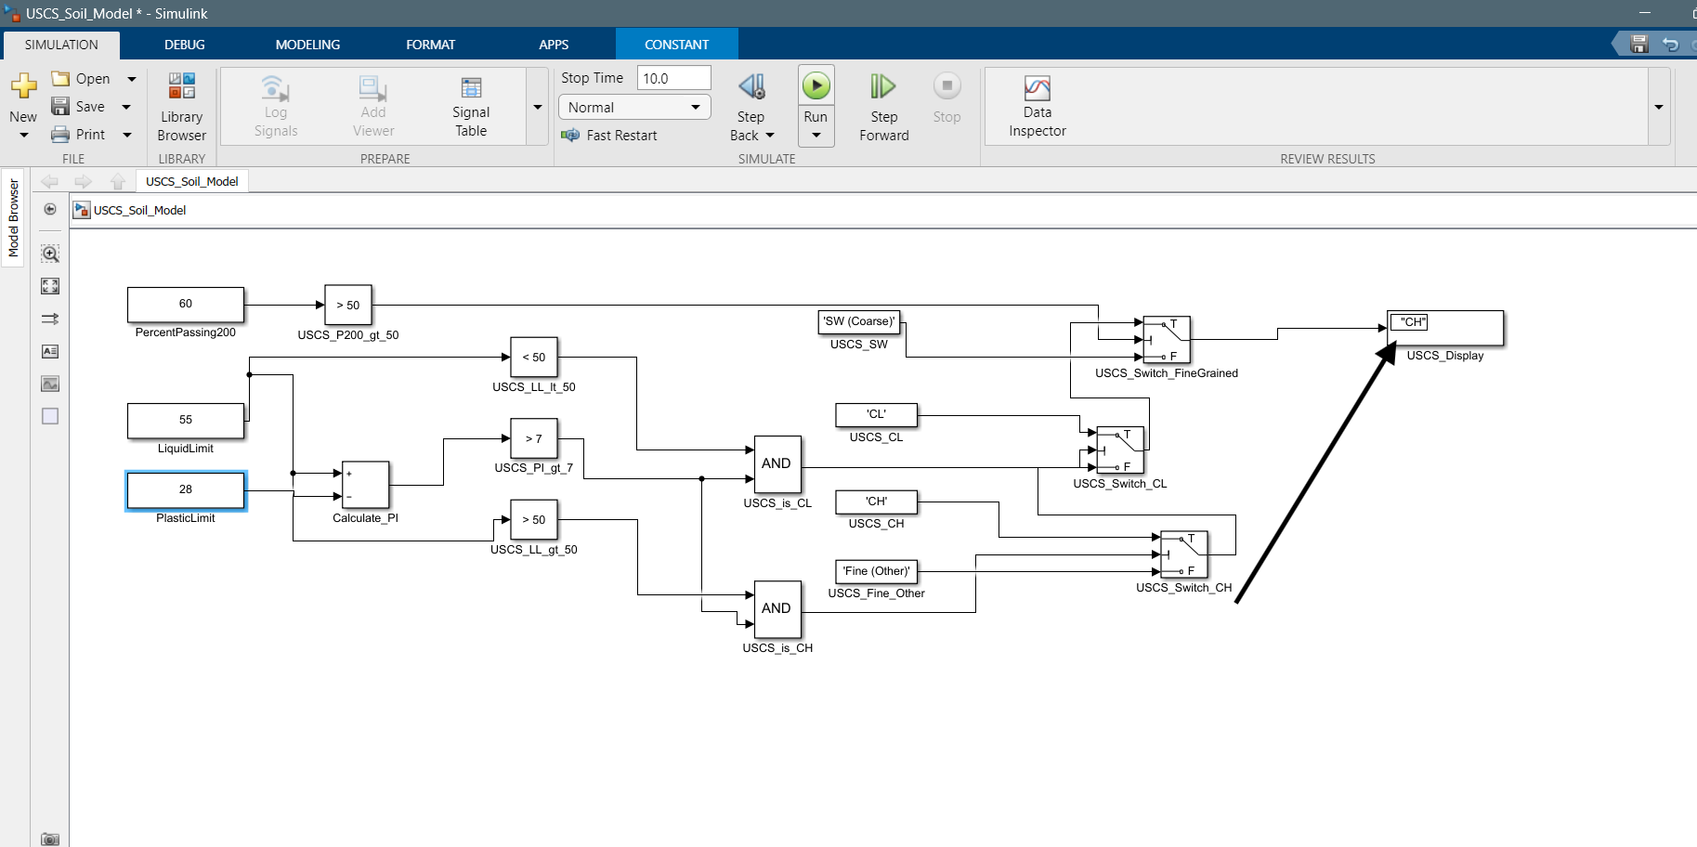
Figure 6:USCS Sample Output
- The AASHTO Model returned: 'A-7-6'
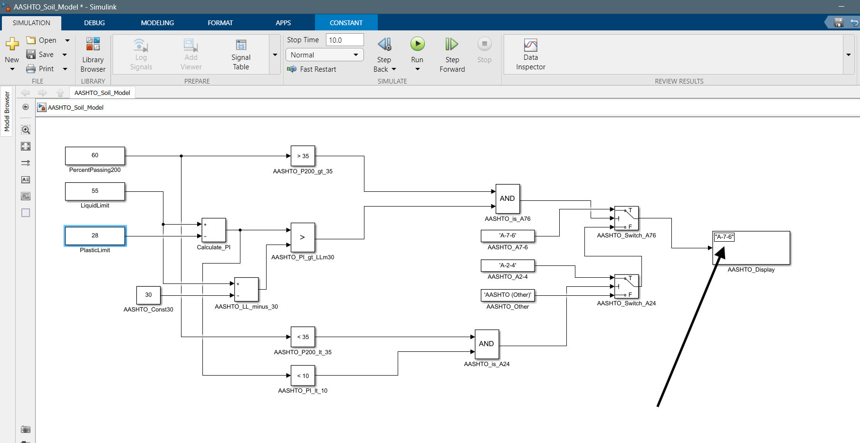
Figure 7:AASHTO Sample Output
The results confirm that the models are correctly classifying the soil according to each system's rules for the given inputs.

